RINEX PROJECT REPORT

***SELF INTRODUCTION:***

NAME: S. HARINE

COLLEGE: MOTHER TERESA POST GRADUATE AND RESEARCH INSTITUTE OF HEALTH SCIENCES

YEAR: IV TH YEAR

1.MAJOR PROJECT - I

Choose any dataset of your choice and apply a suitable ML technique and if possible deploy it using Heroku and Streamlit(COMPULSORY).

GIT HUB LINK:

<https://github.com/harine12/RINEX-MAJOR-PROJECT-1.git>

HEROKU APP LINK:

<https://rinex4mayharine.herokuapp.com/>

SOURCE CODE:

MODEL:

import pandas as pd

df = pd.read_csv('https://raw.githubusercontent.com/harine12/RINEX-MAJOR-PROJECT-1/main/ford.csv')

df

df.info

df.shape

#DATA CLEANING

df_numeric = df.select_dtypes(include = ['float64','int64'])

df_numeric

df_numeric.info

#divide the data into input and output

#input - All the columns except price

#output - price column

x = df_numeric.loc[:, df_numeric.columns != 'price'].values

x

y = df_numeric.loc[:, 'price'].values

y

#TRAIN AND TEST VARIABLES

from sklearn.model_selection import train_test_split

x_train,x_test,y_train,y_test = train_test_split(x,y,random_state = 0)

print(x.shape)

print(x_train.shape)

print(x_test.shape)

print(y.shape)

print(y_train.shape)

print(y_test.shape)

#APPLY LINEAR REGRESSOR

from sklearn.linear_model import LinearRegression

model = LinearRegression()

#FITTING THE MODEL

model.fit(x_train,y_train)

#PREDICTING THE OUTPUT

y_pred = model.predict(x_test)

y_pred

y_test # actual output

print(y_train[10])

model.predict([x_train[10]])

from sklearn.metrics import r2_score

r2_score(y_test,y_pred)

import joblib

joblib.dump(model, 'Linear regression model')

APP.PY:

import streamlit as st

import joblib

import pandas

model = joblib.load('Linear regression model')

st.title('LINEAR REGRESSION MODEL FOR PRICE OF USED CARS')

year = st.number_input("year", min_value=1996, max_value=2060)

mileage = st.number_input("mileage", min_value=1, max_value=200000)

tax = st.number_input("tax in euros", min_value=0, max_value=600)

mpg = st.number_input("miles per gallon", min_value=10, max_value=203)

engineSize = st.number_input("Engine size in litres", min_value=1.0, max_value=5.0, step=1., format="%.2f")

input_data = [[year, mileage, tax, mpg, engineSize]]

pred = model.predict(input_data)

if st.button('Predict car price (in euros)'):

st.subheader(pred)

HEROKU SCREENSHOTS:

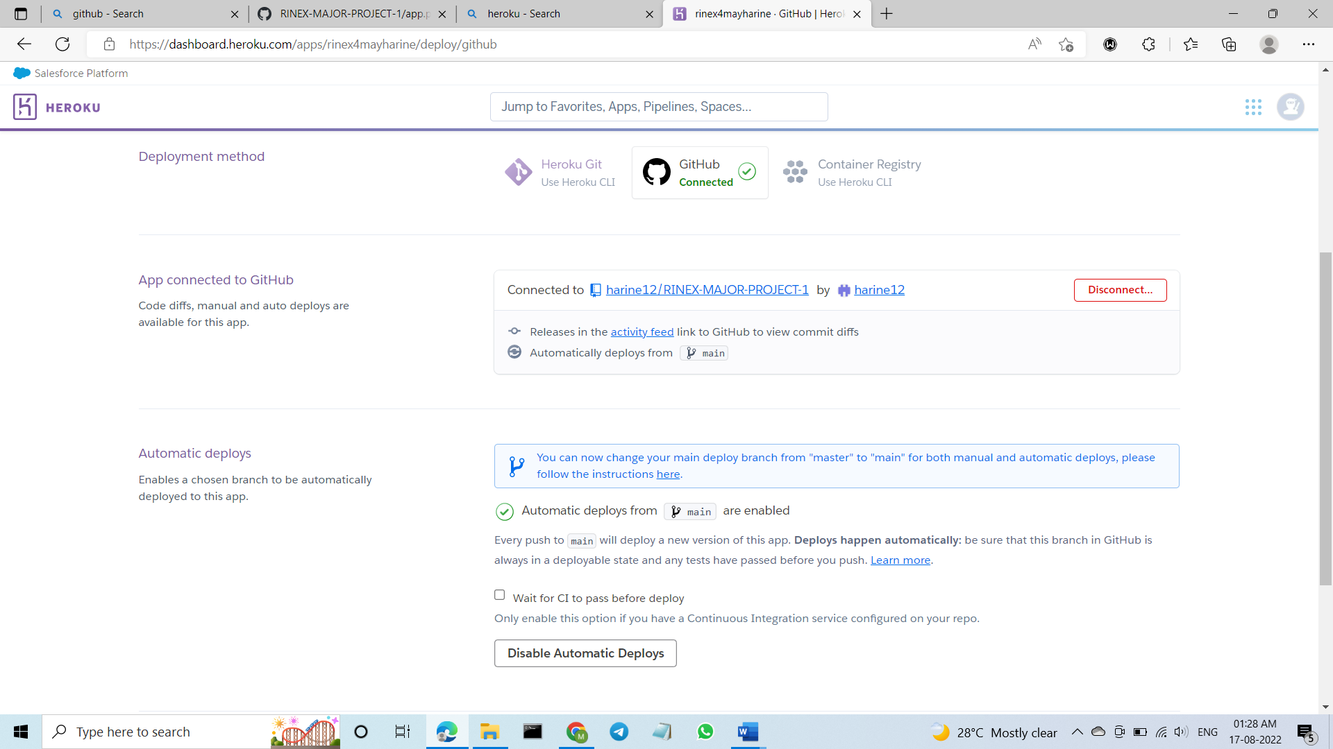

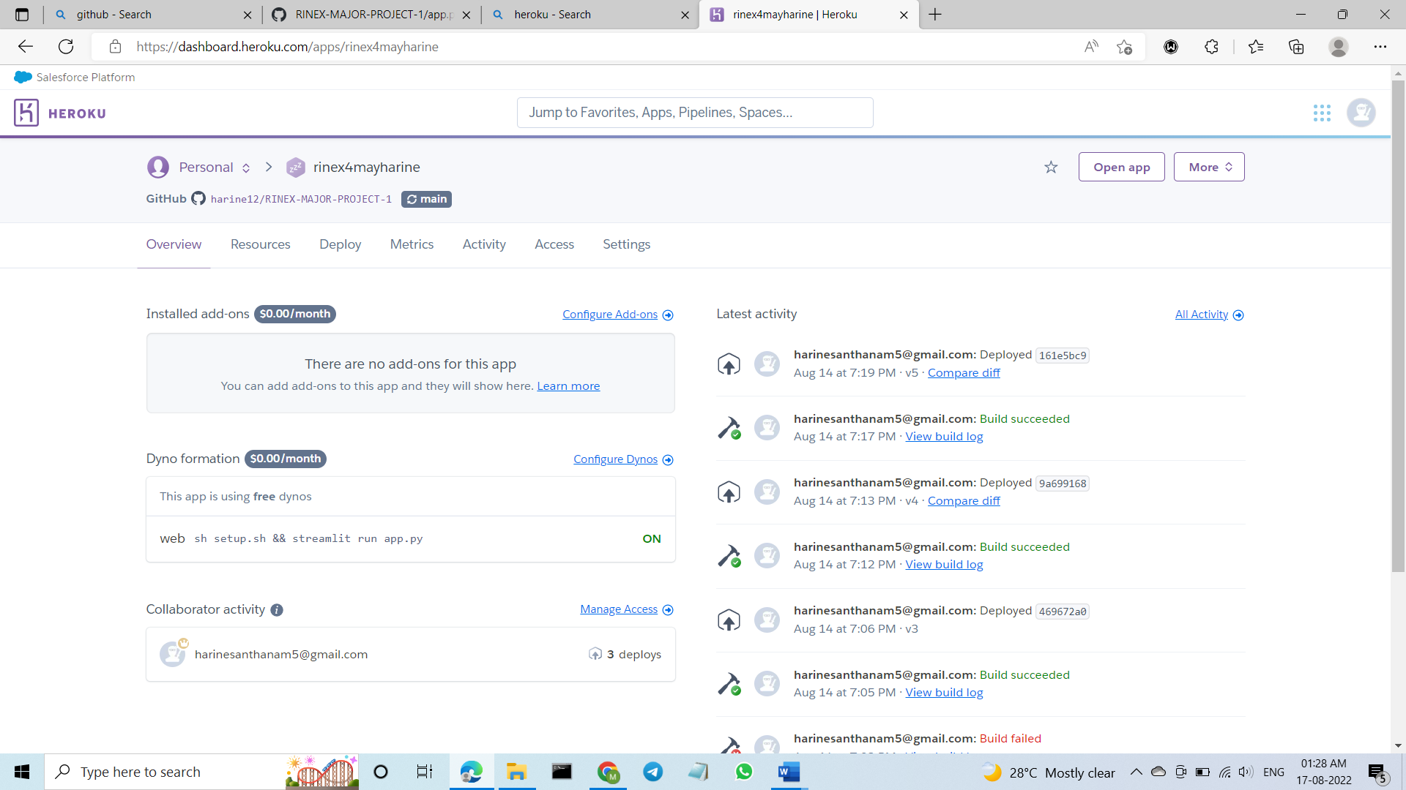

2. MAJOR PROJECT – II:

(a).Take any dataset and perform Exploratory Data Analysis(EDA)

EDA should be done for atleast 15 different parameters/Analysis

GIT HUB LINK:

<https://github.com/harine12/RINEX-MAJOR-PROJECT-2.git>

THANK YOU